|  |
| --- |
| 新东方在线英语学习 |
| 新概念 1 册 |
| Lesson99-100 |



扫一扫。更多有趣的英语资讯。

1. ow: int.哎哟ai ou
2. slip: v.滑倒，滑了一脚3.fall: fel fallen v.落下跌倒

fel fai ao fallen fao len d

1. 4.downstairs: adv.下楼

go downstairs

1. hurt: v.伤，伤害，疼痛hurt- hurt- hurt
   1. hurt oneself I hurt myself.
   2. hurt+ 部位

She hurts her left arm.

1. back: n.背

my back, 我的背

the back door 后门7.stand up : 起立，站起来8.help: v.帮助

Can I help you? Let me help you.

1. at once: 立即

right now

1. sure: adj.一定的，确信的Are you sure?

11.X-ray: n. X 光透视rui

have an X-ray

1. I slipped and fell… slipped- fell

他进来坐下了。

He came in and sat down.

我过来见了他的朋友 Lucy.

# Lesson 99 单词讲解

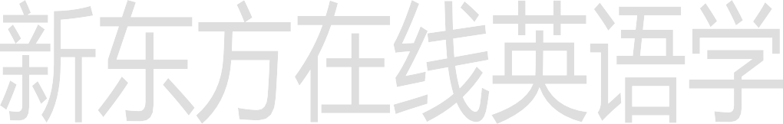**Lesson 99 课文讲解**

I came and met his friend, Lucy.

1. I think that I’ve hurt my back.
2. Try and stand up.

试着站起来。

Try and have a drink.

1. I’m afraid that…

I’m sorry that…

1. I think the doctor had better… had better 最好…
2. The doctors says that…
3. I’m sure that…

# Lesson 99 语法讲解

宾语从句: 句子作宾语。

I love you.

I think (that) he is awful 划线部分是宾语

零部件：

1. 主句& 从句
2. 引导词：that

She says (that) he loved her. 主谓宾

He knows (that) she has gone.主谓

He is sorry (that) he will leave.主谓

**结论 1: 主句一般现在, 从句任何时态。**我知道他会看电影的。

I know (that) he will watch the movie.

我知道他已经看电影了。

I know (that) he has watched the movie.

我知道他经常看电影。

I know (that) he usually watches the movie.

我知道他正在看电影。



I know (that) he is watching the movie.

宾语从句的功能：

I think (that) …

I believe (that) …

I think (that) it is very good.

Because we learn about what is the PM2.5 and what we must do.

1. 什么是宾语从句？ 句子作宾语。
2. 时态？

主句一般现在, 从句任何时态。

1. 语用功能？

表达观点。

1. licence n. 执照
2. lai sen si

license

driving license 驾照

# Lesson 100 单词句型讲解

**Lesson 99&100 知识拓展**

slip

slip my mind: 忘记了slip of the pen: 笔误

slip of the tongue: 口误It slips my mind.

我给忘记了。

That was only a slip of the pen.

那仅是笔误。

